EXPERIMENT 3 – DATA CLEANING AND DATA TRANSFORMATION

Aim
To clean and transform the credit card fraud dataset by handling missing values, removing duplicate records, performing descriptive statistical analysis, normalizing the transaction amount, encoding categorical data, and exporting the cleaned dataset into a CSV file.

Algorithm
Step 1: Import the Pandas library.
Step 2: Load the credit card fraud dataset from the specified CSV file using pd.read_csv().
Step 3: Display the first five records using df.head().
Step 4: Inspect the dataset structure, number of records, columns, and data types using df.info().
Step 5: Check for missing values in all columns using df.isnull().sum().
Step 6: Remove missing values using df.dropna().
Step 7: Check for duplicate records using df.duplicated().sum().
Step 8: Remove duplicate records using df.drop_duplicates().
Step 9: Generate descriptive statistics such as count, mean, standard deviation, minimum, maximum, and quartiles using df.describe().
Step 10: Display the column names using df.columns.
Step 11: Normalize the amount column using Min-Max normalization and store the result in a new column named amount_normalized.
Step 12: Encode the categorical merchant_category column into numerical values and store the result in a new column named merchant_category_encoded.
Step 13: Export the cleaned and transformed dataset as a CSV file using df.to_csv().
Step 14: Display a message confirming successful export of the cleaned dataset.
Program

import pandas as pd
file_path = r"C:\Users\palan\Downloads\archive (1)\credit_card_fraud_10k.csv"
df = pd.read_csv(file_path)
df.head()
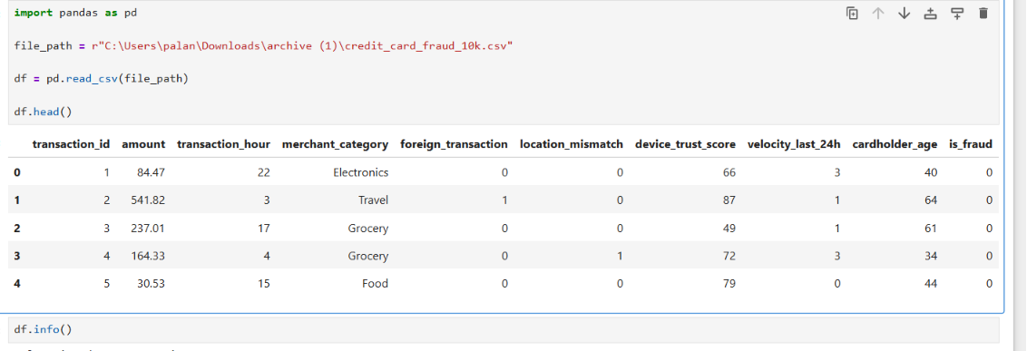
df.info()
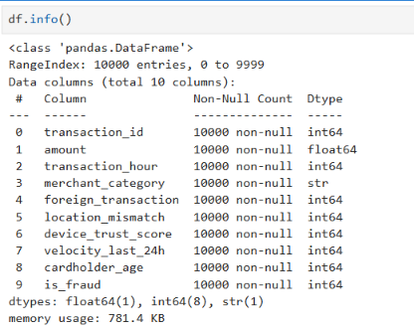
print(df.isnull().sum())
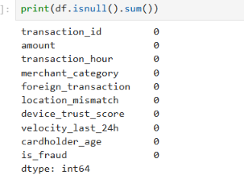
df = df.dropna()
print("Missing values removed successfully")
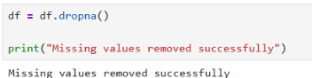
print("Duplicate Records:", df.duplicated().sum())
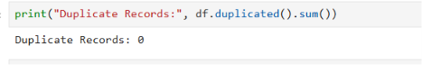
df = df.drop_duplicates()
print("Duplicate records removed successfully")
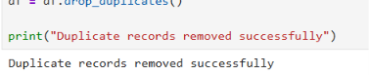
print(df.describe())
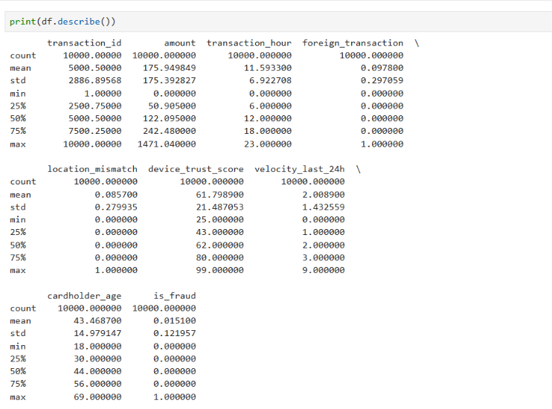
df['amount_normalized'] = (df['amount'] - df['amount'].min()) / (df['amount'].max() - df['amount'].min())
print(df[['amount', 'amount_normalized']].head())
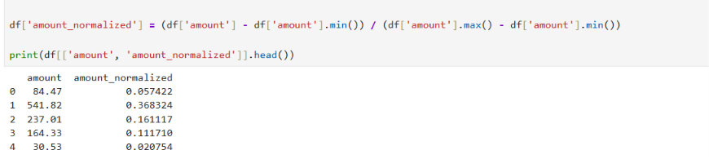
df['merchant_category_encoded'] = df['merchant_category'].astype('category').cat.codes
print(df[['merchant_category', 'merchant_category_encoded']].head())

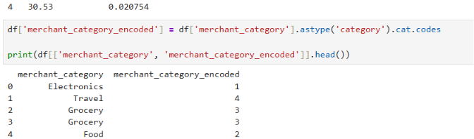
df.to_csv(r"C:\Users\palan\Downloads\cleaned_credit_card_fraud.csv", index=False)
print("Cleaned dataset exported successfully")
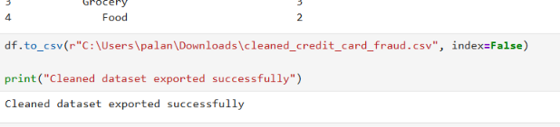
Result:
Thus, the credit card fraud dataset was successfully cleaned, analyzed, transformed, and exported. Missing values and duplicate records were handled, statistical analysis was performed, the transaction amount was normalized, and the merchant category was encoded into numerical values. The final cleaned dataset was saved as cleaned_credit_card_fraud.csv.

